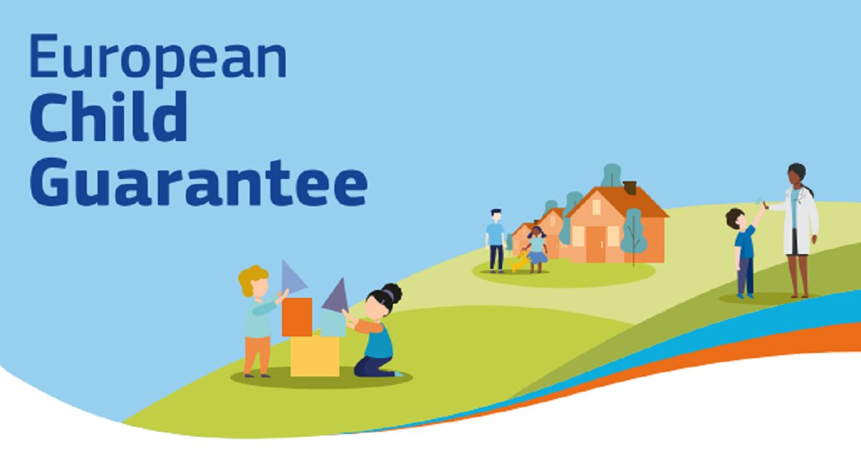

European Child Guarantee Newsletter – No. 9
Dear reader,
The 2026 Commission work programme published on 21 October sets out key strategies, action plans and legislative initiatives that will lay the foundation for the work ahead and help deliver on the ambition to build a strong, secure, and prosperous Europe. You will surely notice the strong focus put on delivering on the Political Guidelines of the current Commission, in particular through the first ever EU Anti-Poverty Strategy and a strengthened European Child Guarantee.
In this context, and as we approach the 20 November - the World’s Children’s Day, our work on the implementation of the European Child Guarantee becomes even more urgent. Addressing child poverty is not only a moral issue, but also an urgent task economically speaking, as child poverty has a cost. By undermining the potential of our youngest generation, by quelling innovative ideas and opportunities, child poverty results in lower productivity. 3.4% of GDP – this is what child poverty costs us each year on average in the EU, according to the OECD.
With this motivation in mind, we invite you to a handful of news on new events and reports relating to our work.

News
European Commission presents its work programme for 2026
On 21 October, the College (plenary meeting of all EU Commissioners) adopted the Commission work programme for 2026. According to President von der Leyen, the document marks “another significant step towards a stronger, more sovereign Europe.” Each year, the work programme informs the public and co-legislators of the Commission’s political commitments to present new initiatives, withdraw pending proposals and review existing EU legislation.
The work programme features six priority areas. Under supporting people and strengthening Europe’s social model heading, Quality Jobs Act, the Fair labour mobility package, and the Education package figure prominently, as well as a series of measures to address the affordability and cost of living crisis. In addition, the first-ever EU Anti-poverty strategy will address structural causes of exclusion and strengthen support services. The strategy will be backed by a strengthened Child Guarantee that will include investments and reforms to tackle child poverty. Read the full 2026 CWP.

Survey on European Child Guarantee open
On the International Day for the Eradication of Poverty (17 October), the European Commission launched a survey to hear from children about their views on the European Child Guarantee.
The online survey will remain open for 7 weeks, until 8 December 2025. It is run via the EU Children's Participation Platform and is part of the Commission's wider commitment to tackling poverty and supporting social inclusion across Europe.
The feedback will contribute to the upcoming Anti-Poverty Strategy and strengthening of the European Child Guarantee.

European Parliament’s Working Group meets to discuss progress and next steps on strengthening the Child Guarantee
The European Parliament’s Working Group on the European Child Guarantee met for the second time in this Parliament’s term on 15 October 2025. The session reviewed achievements such as the expansion of early childhood education, care, and free school meals, as well as the inclusion of candidate countries, while acknowledging persistent challenges around funding, data collection, and coordination. Discussions emphasized the need for more focused and impactful measures, with calls for stronger investment in education, housing, and social services. Civil society representatives highlighted growing child poverty rates across Europe and urged for dedicated EU funding and better tracking of resources, while Members of European Parliament underlined the urgency of delivering tangible progress for children.

Peer Review on social inclusion for families and children in Lithuania
On the 16 and 17 October 2025, the Lithuanian Ministry for Social Security and Labour hosted in Vilinius a Social Protection Committee Peer Review on ‘Social inclusion for families and children’. Peer countries were Czechia, Belgium, Ireland and Austria.
The main objective of the Peer Review was to stimulate an in-depth and detailed discussion on some key aspects of the policy approach regarding equal access to family services in Lithuania, its implementation and challenges around rural-urban disparities, interinstitutional cooperation and the creation of a robust evaluation system.
The participants had the opportunity to reflect and exchange on similar or different policy approaches in the peer countries and potential future initiatives.
All relevant documents will be uploaded shortly here.

Meeting of Child Guarantee Coordinators on adequate housing and alternative care, Copenhagen 6-7 October
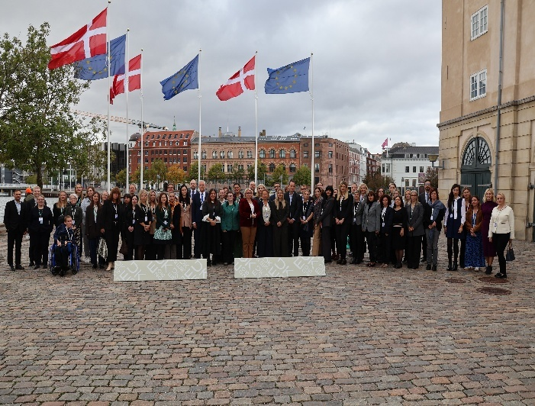
The 22nd meeting of the Child Guarantee Coordinators, held on 6–7 October under the Danish EU Presidency, brought together representatives from EU Member States and candidate and potential candidate countries to exchange best practices on tackling child poverty, improving alternative care, and ensuring access to quality housing. Opening the session, the European Commission highlighted the Child Guarantee’s growing impact and announced forthcoming initiatives, including an EU Affordable Housing Plan and the first-ever EU Anti-Poverty Strategy. Denmark presented its new Child Act and foster care reforms, while participants discussed quality-based family care, data gaps, and the use of EU funds to strengthen implementation. The meeting underscored cross-country cooperation and peer learning as essential to advancing children’s issues and inclusion across Europe.

Join the Online European peer exchange on integrated family support - 19 November
For International Children's Day 2025, COFACE Families Europe will place the spotlight on the European Child Guarantee and its potential to drive positive change for children and their families. This will be done through an online European peer exchange which will focus on the Belgian family centre model referred to as the House of the Child, as a starting point for transnational exchanges and mutual learning with other countries in the EU and neighbourhood countries.
This public webinar will be open to policy makers, and Child Guarantee Coordinators are welcome to join the discussion to share updates on their approaches to integrated family support. Please feel free to share this information with colleagues (practitioners, policy makers and researchers) in your country working at local to national level to implement the European Child Guarantee.
Programme, factsheets and registrations can be found on the COFACE website here.

Child Guarantee outside EU
One of the things that prove the success and importance of the European Child Guarantee is the interest it has received in the EU candidate and potential candidate countries. In fact, nine countries – Albania, Bosnia and Herzegovina, Kosovo^{[1]}, Moldova, Montenegro, North Macedonia, Serbia, Türkiye, and Ukraine – are interested in implementing the child guarantee recommendation already before accession to the European Union. To do so, they have nominated the contact points, who will play a role like that of Child Guarantee Coordinators in the current member states and will start working on strategies/action plans addressing children in need. The Commission has also shared guidance explaining the practicalities of the implementation of the Child Guarantee. An on-line information session for the Contact Points took place in September. On 20-21 November, a further technical meeting financed by the European Commission under the TAIEX Facility will take place in Podgorica (Montenegro).

Read more
New Save the Children Child Poverty Report shows why investment in children is Europe’s most urgent necessity
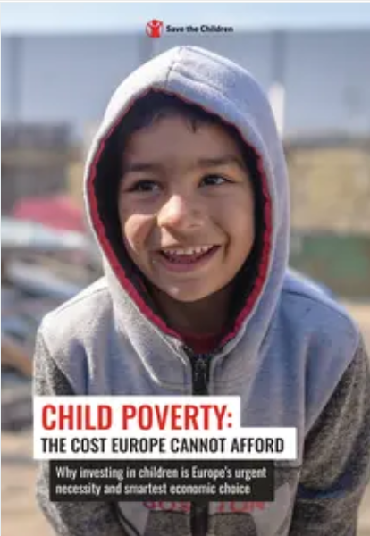
The new report challenges the conviction that child poverty is unavoidable and a phenomenon that Europe lacks the resources to eradicate. It presents a data-driven, rights-based analysis of its scale, its staggering economic and social costs, and the proven solutions that can end it. To achieve its goal of eradicating poverty by 2050, the EU must prioritise the strengthening of its social agenda and ensure adequate investments in children. Read more here.

Global Report on Children’s Care and Protection looks at preventing the separation of children from their families
This SOS Villages International report seeks to deepen understanding of the factors driving the separation of children from their families and their placement in alternative care, across diverse contexts, offering key recommendations for preventing separation. Compiled from research conducted over two years at both global and country levels in collaboration with several academic institutions, this report responds to a growing care crisis that affects millions of children and their families worldwide. Read it here.

Eurochild calls for the Strategic Role of the European Semester in Advancing Children’s Rights and Securing Child-Centred Investments
Eurochild has been analysing the European Semester’s through a children’s rights lens for the past 10 years, providing critical insights into how EU economic and social policies impact children.
In 2025, now in the fourth year of the European Child Guarantee (ECG) implementation, the European Semester Country Reports for all Member States include, for the first time, updates on progress. Eurochild welcomes that each report now summarises the state of ECG implementation alongside information from biennial reports and EU fund allocations. Read more here.

Eurofound: working for children matters: an overview of service delivery and workforce in Europe
Labour shortages – often due to migration of healthcare workers – may undermine equitable access to healthcare services across the EU. This is having a particularly important impact on children, given that the percentage of children reporting very good health has decreased substantially in recent years.
This and many other findings, you will be able to further follow in this new Eurofound report, which analyses trends and disparities in the accessibility of services for children that must be addressed to achieve this. Moreover, given that staff play an integral role in determining the quality and accessibility of these services, this report describes the state of play of staff working conditions and training opportunities. Good working conditions and affordable high-quality services, such as early childhood education and care, also play a key role in encouraging labour market participation and increasing productivity. Read more here.

Young people most affected by severe material and social deprivation in 2024 according to Eurostat
At EU27 level: “In 2024, 6.4% of people in the EU faced severe material and social deprivation, indicating a slight decrease compared with 2023 (6.8%). Young people under 18 were most affected by severe material and social deprivation (7.9%), followed by those aged 18 to 64 (6.4%), and those 65 and older (5.1%). Women had higher rates of severe material and social deprivation than men (6.6% compared with 6.2%). This pattern of higher rates for women was consistent across all observed age groups, except for those under the age of 18.”
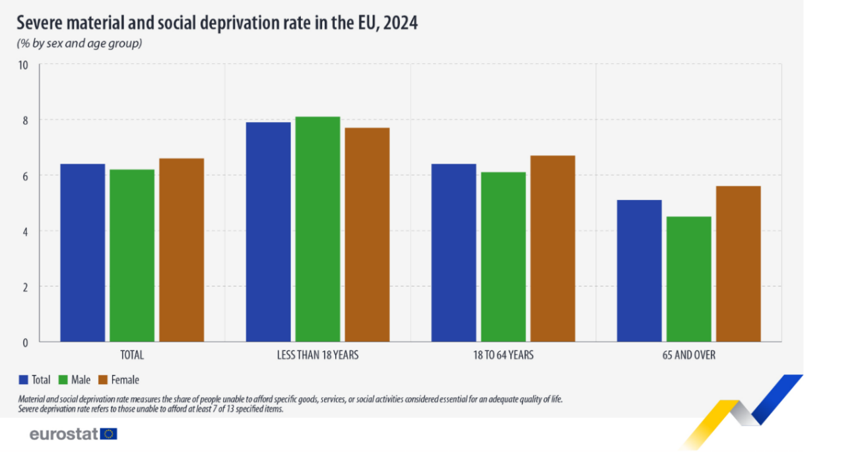
At MS level: “Among EU countries, the highest share of people who faced severe material and social deprivation was recorded in Romania (17.2%), followed by Bulgaria (16.6%) and Greece (14.0%). By contrast, the lowest rates were recorded in Slovenia (1.8%), Croatia (2.0%) and Poland (2.3%).”
More information see: Severe material & social deprivation rate in EU: 6.4% - News articles - Eurostat.

To subscribe to the Newsletter, please contact us at:
EMPL-CHILD-GUARANTEE@ec.europa.eu

[1] Designation without prejudice to positions on status, and is in line with UNSCR 1244/1999 and the ICJ Opinion on the Kosovo declaration of independence

